Description of the Application

The application that I have modelled for this assignment is based of the “Galaxy Zoo” section of the zooniverse.com website. I have chosen this topic due to a great passion for astronomy and space sciences that I have had since a young age and because I spent a lot of time personally contributing to the Galaxy Zoo project. You can view the project at this link for a further description of the project that inspired this implementation.

I chose to implement a mysql solution for the following requirements. Galaxy Zoo is a community driven scientific project. There is a vast amount of data coming from the Hubble Space Telescope’s deep sky views every day. The information that astrophysicists can gain from these images about the formation of early galaxies is invaluable to understanding the life-cycles of these collosal celestial structures. However, due to inadequate computer systems to evaluate these images correctly and a lack of man-power, astronomers working with this data have resorted to having the public inspect and evaluate images of deep-sky objects through easy to use UX features. Users can quickly evaluate 100s of images galaxies and assign classifications based on the shape of a galaxy or any other features that may be present. Users can also take part in a discussion forum to debate particularly controversial galaxies or to share various spectacular images they have encountered and saved to their collection. In summary the following features are required for the system to function as intended.

- Users assign classifications to images of galaxies based on certain observable features such as a merger, spiral arms, shape etc.
- Users can view metadata about galaxies such as the coordinates on the celestial sphere or the date and time the image was taken.
- Users can share particularly tricky examples to a discussion form to help decipher certain features and curiosities about the galaxy.
- Users can also take part in general discussion forums about astronomy and other related topics on site.
- Users can save and share images they find particularly interesting or beautiful to their own collection which they can share on site in the discussion forums as well as share other relevant images.

List of Normalised Relations

<USER>
user_id, email, username, first_name, second_name

<GALAXY>
galaxy_id, image_link, distance, right_ascension, declination, capture_date, capture_time

<CLASSIFICATION>
classification_id, galaxy_id, user_id

<CLASSIFICATION_TYPE>
type_id, classification_id, type

<ODDITY>
oddity_id, classification_id

<ODDITY_TYPE>
type_id, oddity_id, type

<FORUM>
forum_id, title

<THREAD>
thread_id, forum_id, user_id, title

<REPLY>
reply_id, thread_id, user_id, image_link, reply_text

Note: blue_text = Foreign Key

Functional Dependency Diagrams

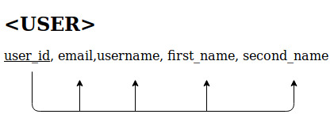

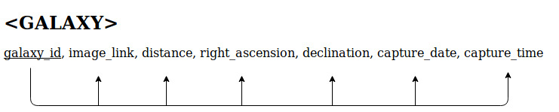
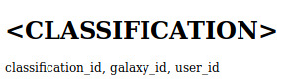

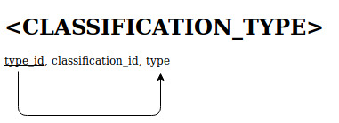

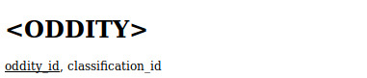

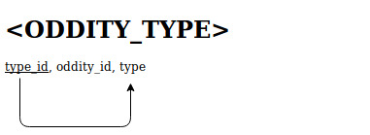

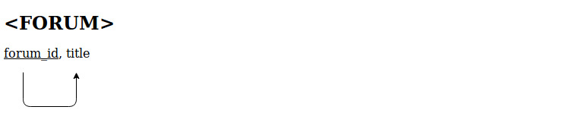

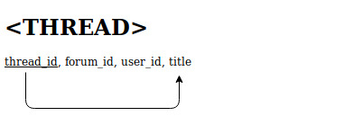

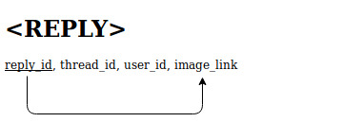

Semantic Constraints
The semantic constraints for such a system, that is, those constraints which for the most part (sometimes there are exceptions) cannot adequately be applied within the relational schema for the given project description are as follows. These constraints should be considered more with respect to the application’s design and not the design of the database.

- A user may only create one classification at a time.
- A user may only maintain one “Collection” at any given time.
- User’s cannot create Forums but can create and reply to Threads within the forums on site.
- Attributes of a Galaxy relation cannot be modified in any way by a general User of the platform. Only Classifications may be made which creates a relation to a galaxy.
- A galaxy may not have more than one classification associated with it. (i.e no two Classifications can contain the same value under the galaxy_id attribute)

